Given an m x n integer matrix grid, return *the maximum****score****of a path starting at*(0, 0)*and ending at*(m - 1, n - 1) moving in the 4 cardinal directions.

The **score** of a path is the minimum value in that path.

* For example, the score of the path 8 → 4 → 5 → 9 is 4.

**Example 1:**

**Input:** grid = [[5,4,5],[1,2,6],[7,4,6]]

**Output:** 4

**Explanation:** The path with the maximum score is highlighted in yellow.

**Example 2:**

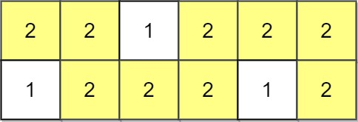

**Input:** grid = [[2,2,1,2,2,2],[1,2,2,2,1,2]]

**Output:** 2

**Example 3:**

**Input:** grid = [[3,4,6,3,4],[0,2,1,1,7],[8,8,3,2,7],[3,2,4,9,8],[4,1,2,0,0],[4,6,5,4,3]]

**Output:** 3

**Constraints:**

* m == grid.length
* n == grid[i].length
* 1 <= m, n <= 100
* 0 <= grid[i][j] <= 109